Configuration Server and Client

- Server Config
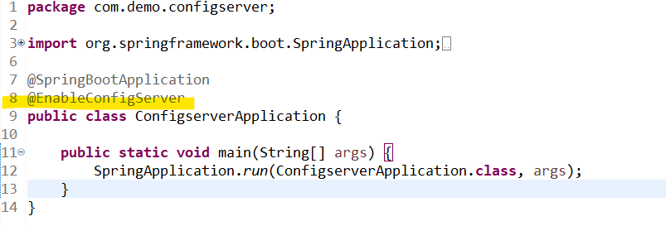

- Client Config : pom.xml

<?xml version="1.0" encoding="UTF-8"?>
<project xmlns="http://maven.apache.org/POM/4.0.0"
xmlns:xsi="http://www.w3.org/2001/XMLSchema-instance"
xsi:schemaLocation="http://maven.apache.org/POM/4.0.0 https://maven.apache.org/xsd/maven-4.0.0.xsd">

<modelVersion>4.0.0</modelVersion>

<parent>
<groupId>org.springframework.boot</groupId>
<artifactId>spring-boot-starter-parent</artifactId>
<version>4.0.6</version>
<relativePath/>
</parent>

<groupId>com.info</groupId>
<artifactId>config-client</artifactId>
<version>0.0.1-SNAPSHOT</version>
<name>config-client</name>
<description>Spring Cloud Config Client</description>

<properties>
<java.version>25</java.version>
<spring-cloud.version>2025.1.1</spring-cloud.version>
</properties>

<dependencies>

<!-- Web API -->
<dependency>
<groupId>org.springframework.boot</groupId>
<artifactId>spring-boot-starter-web</artifactId>
</dependency>

<!-- Spring Cloud Config Client -->
<dependency>
<groupId>org.springframework.cloud</groupId>
<artifactId>spring-cloud-starter-config</artifactId>
</dependency>

<!-- Lombok -->
<dependency>
<groupId>org.projectlombok</groupId>
<artifactId>lombok</artifactId>
<optional>true</optional>
</dependency>

<!-- Test -->
<dependency>
<groupId>org.springframework.boot</groupId>
<artifactId>spring-boot-starter-test</artifactId>
<scope>test</scope>
</dependency>

</dependencies>

<dependencyManagement>
<dependencies>
<dependency>
<groupId>org.springframework.cloud</groupId>
<artifactId>spring-cloud-dependencies</artifactId>
<version>${spring-cloud.version}</version>
<type>pom</type>
<scope>import</scope>
</dependency>
</dependencies>
</dependencyManagement>

<build>
<plugins>

<plugin>
<groupId>org.springframework.boot</groupId>
<artifactId>spring-boot-maven-plugin</artifactId>
</plugin>

<plugin>
<groupId>org.apache.maven.plugins</groupId>
<artifactId>maven-compiler-plugin</artifactId>
<configuration>
<annotationProcessorPaths>
<path>
<groupId>org.projectlombok</groupId>
<artifactId>lombok</artifactId>
</path>
</annotationProcessorPaths>
</configuration>
</plugin>

</plugins>
</build>

</project>

- Client Side setup

- Application.yml (where we connection to the server side)

spring:
application:
name: configdemo
profiles:
active: default
config:
import: optional:configserver:http://localhost:8888

build:
id: ${ID}
version: ${VERSION}
name: ${NAME}

- import: optional:configserver:http://localhost:8888 ( is the server url where we connect to the server config)

- Testing

- GET: http://localhost:8888/configdemo/dev
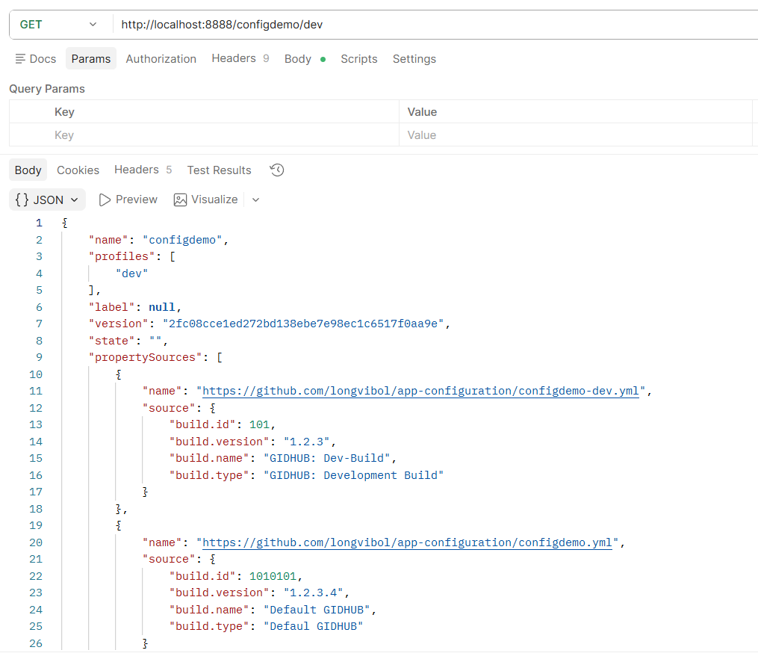

- GET: http://localhost:8080/build-info

Note: in the importance is anotatin @RefreshScope

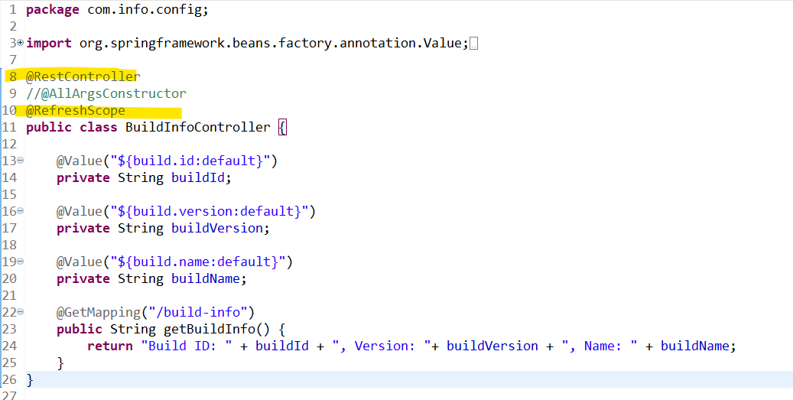

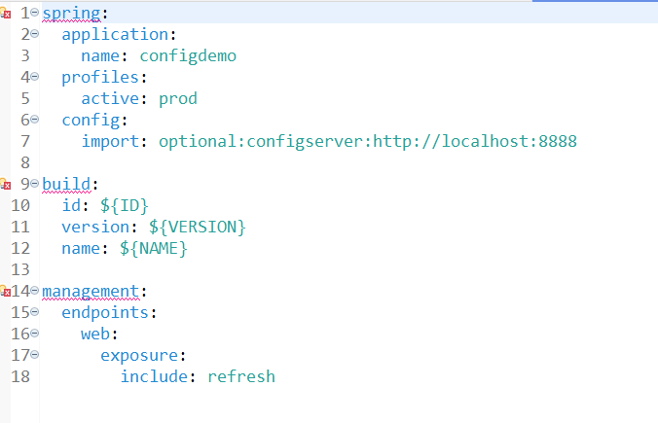

spring:
application:
name: configdemo
profiles:
active: prod
config:
import: optional:configserver:http://localhost:8888

build:
id: ${ID}
version: ${VERSION}
name: ${NAME}

management:
endpoints:
web:
exposure:
include: refresh

@RestController
//@AllArgsConstructor
@RefreshScope
public class BuildInfoController {

@Value("${build.id:default}")
private String buildId;

@Value("${build.version:default}")
private String buildVersion;

@Value("${build.name:default}")
private String buildName;

@GetMapping("/build-info")
public String getBuildInfo() {
return "Build ID: " + buildId + ", Version: "+ buildVersion + ", Name: " + buildName;
}
}

